**NATIONAL UNIVERSITY OF COMPUTER & EMERGING SCIENCES**

**KARACHI CAMPUS**



**PROJECT REPORT**

**DIGITAL DICE**

**USING 4017 & 555**

**DLD**

**EE-227**

**Section: E**

**Group Members:**

**Ali Nadir 20k-0325**

**Imtiaz Ali 20k-313**

**Kanwar Muzammil 20k-0469**

**Ahmed Abdullah 20k-047**

**INTRODUCTION**

**ABSTRACT**

This hardware project will allow user to generate conventional dice patterns representing outputs 1 to 6 using timers and counters, which will be visualized using an LED grid. Push button will be held to roll the dice and released to produce a randomized LED output. The output chosen depends on the point of release. Ultimately, this project can be applied to board games and digital signboards. The project spans concepts such as actuation, logical operations involving AND, OR, NOT gates, and conversion of analogue input to digital data and vice versa. The project also makes use of cascaded flip flops and their toggle transition states to enable counter for the pulses

**Brief Overview:**

1. This project aims to develop an electronic, randomized dice that is capable of generating any of the 6 possible resultant combinations (1 to 6) in the form of a matrix
2. The project also simulates the rolling/shuffling of the dice by pressing and holding a button
3. Enables randomized and unbiased pattern generation.
4. The pattern generated is represented by illuminated LEDs
5. Circuit developed produces and displays the sequence of LEDs representing a dice value
6. The project spans combinational circuit techniques

**Stages Involved:**

* The circuit can be categorized into 3 groups:
  + **Astable Clock Pulse Generation**
  + **Pulse Counting**
  + **Translation of counted pulses into LED output**
* The project has been implemented on breadboards
* Project was first tested using software simulation through Proteus
* Circuit was redesigned and validated before assembly
* All three stages of project were completed in sequence
* The astable pulses form the first stage
* The counting phase forms the second and takes the input from first stage
* At this point, processing has been fully completed i.e. patterns can now be wired
* Third stage covers the translation of wired connections to visual output using LEDs

**METHODOLOGY**

**LOGIC:**

* Clock pulses are generated using an astable IC which constantly produces HIGH and LOW states
* Incoming clock pulses are counted incrementally using a Johnson decade counter, of which 6 pins are routed through parallel combinations of resistors which are grouped in 4
* The number of resistors to each pin of the counter show the number of outputs in a group (total 4)
* The 4 groups represent the combinations of LEDs that must illuminate when a pattern is generated
* Finally, these 4 groups of outputs are connected to LEDs by means of transistors

**Astable Clock Pulse Generation:**

* **Astable Multivibrator mode of 555 timer IC** is also called **Free running or self-triggering mode**. Unlike Monostable Multivibrator mode it doesn’t have any stable state, it has two quasi stable state (HIGH and LOW). No external triggering is required in the **astable mode**, it automatically interchange its two states on a particular interval, hence generates a rectangular waveform. This time duration of HIGH and LOW output has been determined by the external resistors (R1 and R2) and a capacitor(C1). Astable mode works as an **oscillator circuit**, in which output oscillate at a particular frequency and generate pulses in rectangular wave form.
* Using 555 timer IC, we can generate precise time duration of HIGH and LOW output, from micro seconds to hours, that’s why 555 is very popular and versatile IC.
* Because of their availability and ease of use, the 555 astable circuit is the common source of clock signal in many synchronous circuits. A shift register--an example of a synchronous circuit--is shown below. Normally you would connect the output of the 555 astable circuit to the clock pin of this shift register.
* As the clock output varies, the 4017 IC is interrupted, which in turn activates the counting process. This leads to the initiation of the second stage.

**Pulse Counting:**

* This stage makes use of the 4017 IC that determines which of the 6 patterns are activated by enabling combinations of its output pins.
* The circuit starts at clock pin, here we pull down the clock pin to ground through a 1KΩ resistor. This is to be done because the binary counter is a rising edge type. So, whenever a positive rising edge is generated at clock pin, the counter recognizes it as an event and increments the binary output by one.
* Now the clock is provided with a button, so for every button press there will be a positive peak at the clock pin and hence an event. The DECADE counter has a capability to drive the LED directly so there is no need for resistors at the end of binary counters LEDS. The MR (Master Reset) of binary counter must be pulled down at any time, leaving it open might cause unpredictable results as the LEDS might blink randomly. This is ensured by connecting pin 5 to pin 15 of the counter IC.
* So, every time a peak is passed the counter considers it as an event and increments the output by one for every passing event, once it reaches its limit to track the events, it automatically resets to zero and starts again to count the pulses.

**Translation of Output:**

* Outputs of the Counter IC each represent the 6 possible patterns which could result from a roll
* The outputs have been grouped for reuse in other patterns
* A total of 4 groups are created, in which series and parallel arrangements of resistors are used
* Specific combinations of these groups are connected to transistors
* The transistors bridge the parallel combinations of output pins to LEDs that have been arranged to resemble one face of a die
* Depending on the point of button release, a particular sequence of LEDs is triggered by the counter that visualizes the corresponding pattern
* Some LEDs remain dimmed, while the others are illuminated, in a total of 6 possible ways which correspond to the 6 faces of a die.

**ELECTRONIC COMPONENTS**

* 1x 555 Timer IC for pulse generation:
  + Used to implement stage 1
* 1x 4017 IC to receive and count pulses
  + Used to implement stage 2
* 8x LED for output
  + Provides visual output for dice pattern
* 4x transistors
  + Used to group the outputs for reuse. 4 used since 4 groups are formed
* 5x 220K and 12x 10K resistors for surge protection/load distribution
  + The resistors absorb the current and prevent the components from being burned or shorted due to high current
* 1x 1uF, 1x 0.01uF capacitors
  + Capacitors are used to delay the pulses sent by the timer IC to the 4017 counter IC
* 1x push button
  + Used to trigger the circuit to switch between outcomes
* 3 breadboards
  + Used to assemble the circuit in the three stages defined

**SOFTWARE USED**

* The software chosen for hardware circuit design, simulation, and testing is Proteus 8
* Allowed for careful study of circuit for better understanding
* Chosen for its rich library of electrical components, including various microcontrollers, and debugging tools, such as plotters and oscilloscopes
* Easy to use and up to date with latest hardware conventions
* Simulation created has been attached in PowerPoint presentation
* All three stages were individually developed in Proteus.
* Various ground and voltage connections have been made
* The entire circuit is essentially a closed loop with multiple parallel connections running across
* The connections were quite simple to make. Proteus also allows the circuit to be rearranged in a tidier manner
* The simulation occurs in real time

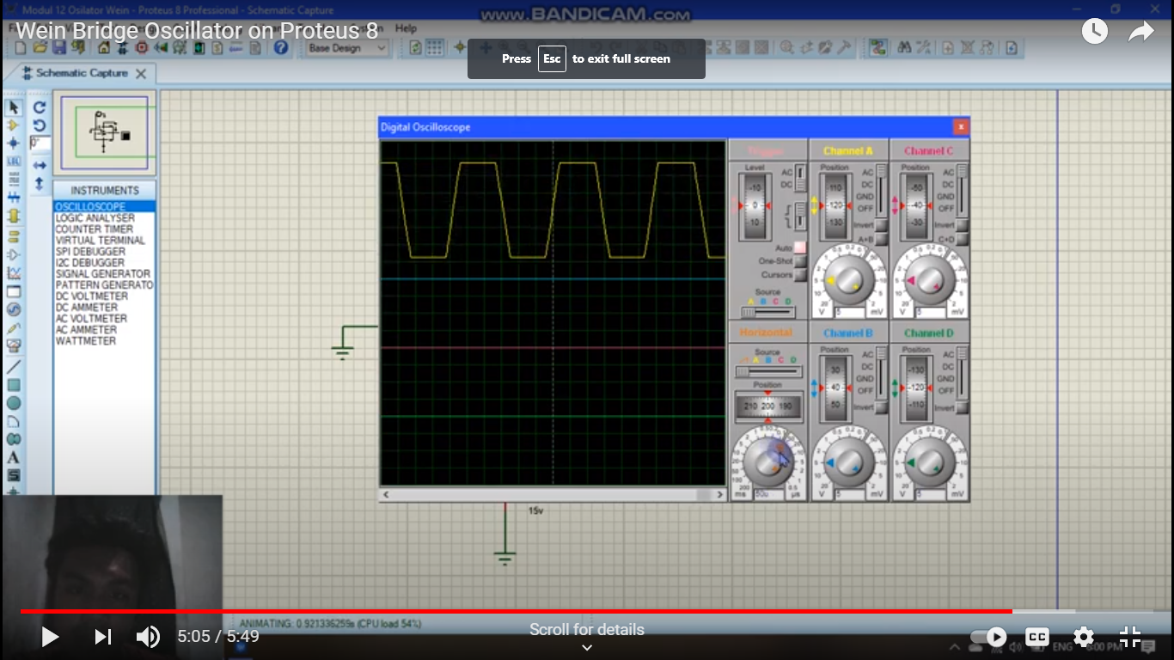

* An example of an oscillator used to detect and show wave pulses

in Proteus

**FLOW DIAGRAM**

GENERATE FREQUENCY

PIN 1 HIGH

Call A()

IS BUTTON RELEASED?

IS BUTTON RELEASED?

IS BUTTON RELEASED?

PIN 2 HIGH

CALL A(),B()

PIN 6 HIGH

CALL B. C D

YES

YES

YES

NO

SAME FOR PINS 3 TO 6

READ BUTTON PRESS

TIMER 555 CREATES PULSE

4017 COUNTER IC

PAUSE FOR BUTTON

PRESS

**ALGORITHM**

* Timer IC feeds a clock pulse to 4017 counter IC
* Clock frequency disturbs the counter to enable it
* Initially, the circuit triggers first pin of the 4017 IC by default
* This can be seen by illumination of central LED which indicates ONE
* The program then checks for button release
* If YES, the program prompts the user for input i.e. to detect the next button press
* This allows the program to pause and display the last sequence of LEDs enabled
* Else, if the button remains pressed, the circuit activates the second pin
* Groups A, B, C and D represent resistors/LEDs arranged in parallel
* The same check for pin 1 is reapplied and thus program loops through all 6 output pins
* This is visualized by the LEDs cycling through all 6 patterns of the dice until button is released (1 through 6)

**CIRCUIT DIAGRAM**

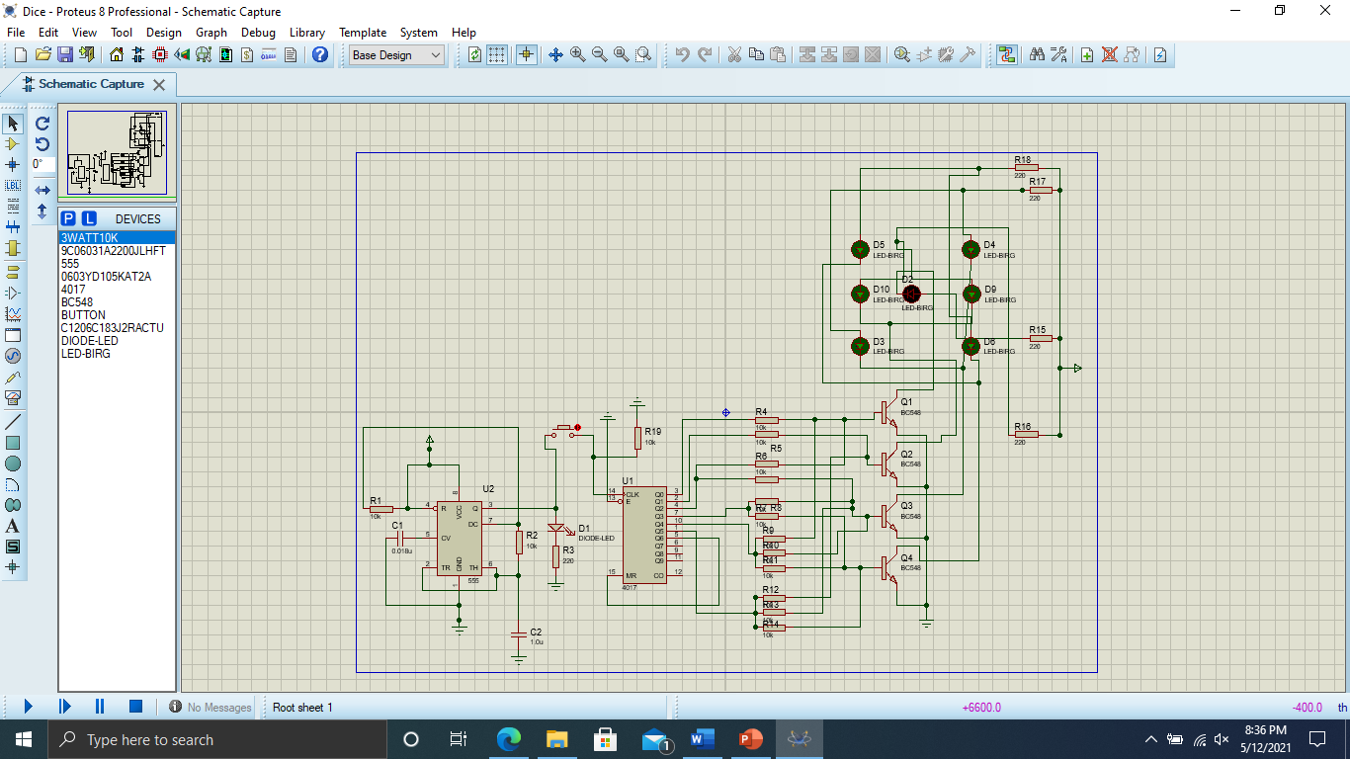

* Group B: LED D9 and D10
* Group A: LED D2

**RELEVANT LED GROUPS ACTIVATED**

* Group C: LED D3 and D4 **D C**
* Group D: LED D5 and D6

**B**  **A B**

**BUTTON TO INTERRUPT COUNTER**

**TIMER PIN 3 CONNNECTED TO 4017 PIN 14**

**C** **D**

**A**

**B**

**C**

**D**

**LABELED OUTPUTS AND EXPLANATION:**

* U1 and U2 are the 4017 and Timer 555 ICs respectively
* Output pin 3 of Timer 555 clock forms input to pin 14 of 4017 IC
* A transistor represents 1 of 4 groups of LEDs (A, B, C, D), each of which is comprise of two or more LEDs
* The number of junctions converging at each transistor represents the number of patterns which use a particular LED group
* If the counter returns to stable state, the circuit is paused and a only particular face of the die is displayed
* Pattern here means the **illuminated sequence** of the dice (the number obtained after a roll) on 7 led grid shown below
* For e.g. singular group A has 3 paths since it is used in patterns 1, 3, and 5 as shown on next page
* Similarly, group C has a total of 4 paths since it is utilized in patterns 3, 4, 5, 6
* Pin 5 of counter is connected to pin 15 for resetting the IC
* Group B has 2 total paths corresponding to patterns 2 and 6
* Group D has 2 junctions, or 3 branches, that correspond to outputs 4, 5, and 6
* These groups are arranged in parallel (where applicable)
* Each branch is connected to 10K Ohm resistors for load distribution to prevent transistors from shorting

**WORKING AND IMPLEMENTATION**

* Upon powering on the circuit, pin 1 of U2 is enabled by default
* This is reflected by illumination of center most LED on output grid
* The user presses and holds the push button for as long as desired
* Thus, the user emulates a dice roll
* Releasing the button stops the roll and illuminates certain LED groups
* Grouped LEDs shown above
* Pattern displayed remains lit until the dice is “rolled” again
* The pattern seen depends on where in the sequence the counter is interrupted
* Once this interrupt is detected, the circuit pauses and awaits next button push
* Since counter moves linearly, patterns for 1 to 6 are seen successively in correspondence
* Functionality is maintained by looping this counter to the first pattern i.e. central LED

**LED FORMATION AND COUPLING:**

D1

D2

C1

C2

B1

B2

A

* **Different LED groups used in combination for specific outputs**
* **Some remain enabled while others are disabled to give visual result**

**OUTPUTS**

|  |  |
| --- | --- |
| **OUTPUT / PATTERN NUMBER** | **GROUPS INVOLVED** |
| **1** | **A** |
| **2** | **B** |
| **3** | **A + C** |
| **4** | **C + D** |
| **5** | **A + C + D** |
| **6** | **B + C + D** |

* **1: Group A**
* **2: Group B**
* **3: Groups A + C (Parallel)**
* **4: Groups C + D (Parallel)**
* **5: Groups A + C + D (Parallel)**
* **6: Groups B + C + D (Parallel)**

**APPLICATION**

* The primary application implemented is a rollable die for board games. Normally, physical dice suffer wear and change the probability of an outcome. With digital dice, outcomes always remain unbiased and completely random.
* Although the application demonstrated may only pertain to small scale board and puzzle games, this dice algorithm can be advanced and improvised to cover broader applications in both software and hardware, such as shuffling in a card game. This digitizes and embeds the entire circuit in software, and only the visual representation of the output is changed (cards as opposed to patterns). The counter mechanism remains unchanged.
* A more robust hardware driven application involving dice could be a digital signboard. The first two stages for pulse generation and counting remain fairly similar for signboards, but the output representation is entirely different. Firstly, instead of dice, a far larger RGB grid can be used whose elements can be individually programmed. An alternative implementation would follow the three aforementioned stages without variation, but will extend the outputs by connecting and configuring a grid/matrix to the transistors and LEDs.

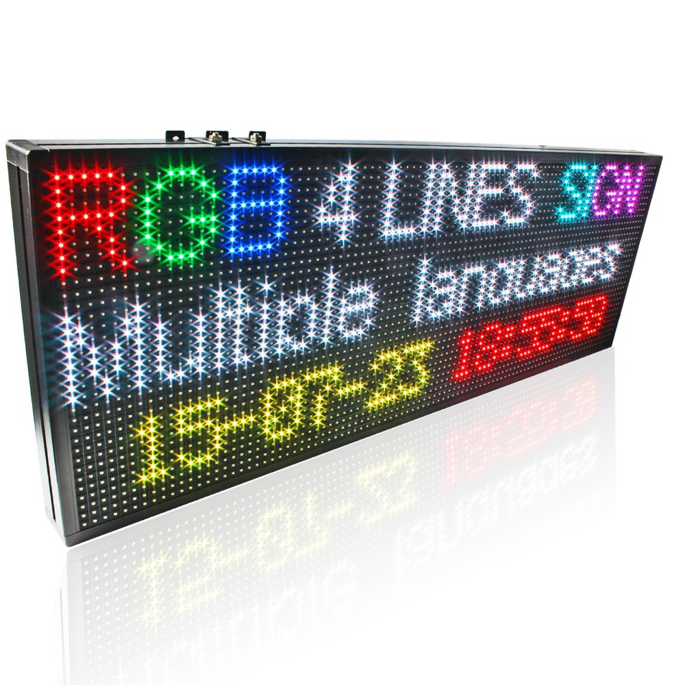

**An RGB matrix can be used to extend the existing dice circuit to form a 2nd output stage**

* As explained, this circuit is usually applied in cases where output needs to be visualized and pronounced.
* Any application that involves random numbers can be associated with the circuit developed.
* This circuit can also be used in lucky draw systems to pick a number, or pattern, randomly. Such an application can then optionally be further extended to display the results on a matrix, as previously discussed.

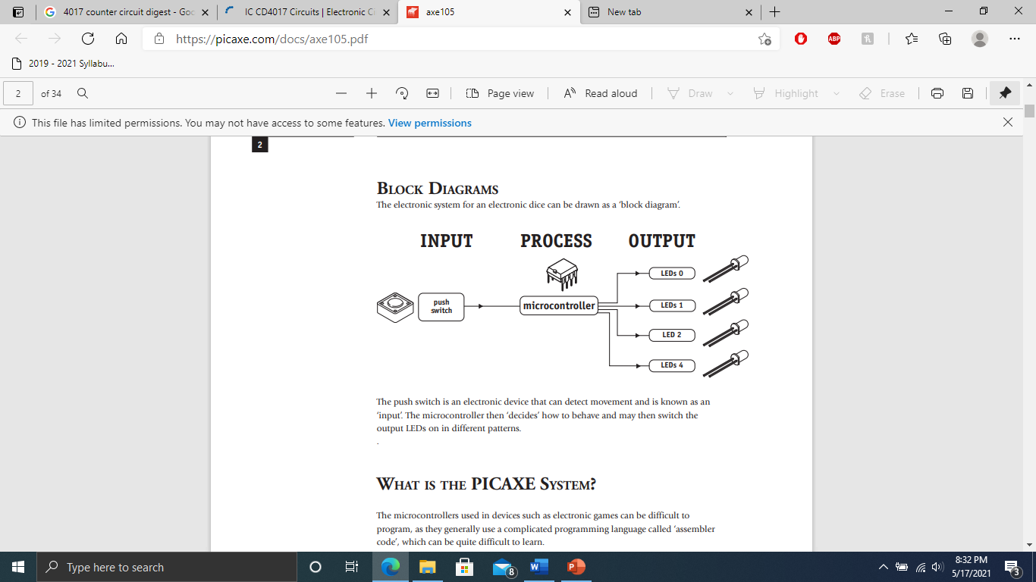

**MOTIVATION**

What initiated this project was curiosity of the working and functionality of an electronic, hardware based random number generator. With this in view, a number of systems can be built to enable a particular pattern based on the random number generated. To implement such a system, a microcontroller capable of generating random numbers was needed. This led to the first and second stages of the project to be decided, since a clock pulse would be fed to the required microcontroller device to activate it. Since the project would use random numbers for processing, each number had to correspond to certain distinct output. In our case, this could be a group of LEDs coupled to resemble the faces of a die. This perfectly incorporates the 4017 counter IC, which utilizes counting, a crucial application of flip flops. In order to develop patterns similar to those of a die, certain LEDs would need to correspond to each other, which led to the idea of LED coupling. Desire for exploration of the working of microcontrollers and its integration in random number generation, and eventually electronic dice, proved to be our main motivator. Thus, our group decided to create digitized dice for use in board games (ludo snakes and ladders etc.) and on a larger scale in digital signboard, matrix etc.

**TASK DISTRIBUTION**

|  |  |
| --- | --- |
| HARDWARE | SOFTWARE |
| Imtiaz Ali | Ahmed Abdullah |
| Muzammil | Ali Nadir |

**HARDWARE:**

* Assembly:
  + First Stage: Kanwar Muzammil
  + Second Stage: Imtiaz Ali
  + Third Stage: Imtiaz Ali
* Wiring and connections: Imtiaz Ali
* Testing and debugging: Imtiaz Ali, Kanwar Muzammil
* Research: Imtiaz Ali
* Selection of components: Kanwar Muzammil, Ahmed Abdullah

**SOFTWARE:**

* Circuit design: Ali Nadir
* Software implementation: Ali Nadir, Ahmed Abdullah
* Simulation: Ali Nadir
* Testing and debugging of design: Ali Nadir, Ahmed Abdullah

**PRESENTATION:**

* Ali Nadir
* Ahmed Abdullah
* Imtiaz Ali
* Kanwar Muzammil

**MISCELLANEOUS:**

* Both teams collaborated regularly to ensure the functionality and timely completion of the circuit
* The software phase was completed first to reduce trial and error and to simplify the design of the circuit
* All changes and revisions were first discussed, simulated, and then implemented

**CONCLUSION:**

* System developed to cater to small scale board and card games
* The algorithm can be extended to allow for larger scale applications such as digital signboards in airlines and traffic systems
* The circuit function relies on button press which is registered as input
* The latency of the input determines one of 6 patterns/outcomes that can be generated
* The output patterns are represented in the form of LEDs
* Allows for continuous dice rolls for extended periods
* Purely unbiased and randomized results every time due to even frequency of an outcome’s occurrence
* This project greatly enhanced our understanding of combinational logic, microcontrollers, and flip flops along with their applications and also allowed us to brainstorm and explore alternative solutions to the problem proposed

**REFERENCES:**

* [**www.circuitdigest.com**](http://www.circuitdigest.com)
* [Make a Digital dice with 555 and 4017 | Digital dice with LEDs - YouTube](https://www.youtube.com/watch?v=dIamTa-B5ds&ab_channel=EEWave)